DO DOGS KNOW CALCULUS?
B
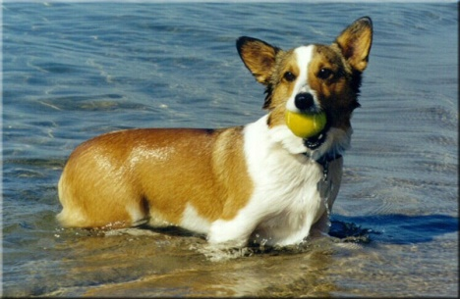 Dr. Elvis
x

A
C
D
y

z

r = 6.40 m/s running speed
s = 0.91 m/s swimming speed
T = total time = time running + time swimming
$$T\left(y\right)=\frac{AD}{r}+\frac{DB}{s}$$
$$=\frac{z-y}{r}+\frac{\sqrt{x^{2}+y^{2}}}{s}$$

z = 15 m
x = 10 m

min_ y T(y)
FOC $T^{'}\left(y^{*}\right)=0 ή \frac{dT(y^{*})}{dy}=0$
SOC $Τ^{''}\left(y^{*}\right)>0$

