Monetary Valuation of Biodiversity Loss in Greece: Ecological and Ethical Dimensions of WTA Compensation

Abstract
The present study estimates the monetary value of biodiversity within the Greek territory, comparing economic valuation results with the intrinsic biological value of biodiversity as reflected by ecological indicators. “The analysis is framed to capture both individual welfare-based responses and ethically or socially motivated refusals, reflecting the dual nature of biodiversity as a public good. Valuing biodiversity in monetary terms is a crucial step toward effective policy design, particularly amid trends toward market-based conservation (e.g., biodiversity offsetting and “value-to-value” restoration projects). However, monetary valuation of biodiversity faces significant challenges—ranging from methodological issues to practical constraints. Prominent concerns include the hypothetical nature of valuation exercises, the presence of ethical (moral) preferences that reject commodification of nature, and the limited capacity of individuals to fully perceive complex biodiversity assets. This study addresses these issues by carefully selecting a Willingness-To-Accept (WTA) framework aligned with the polluter-pays principle, accounting for ethical and lexicographic preferences (protest responses), and linking ecological information with economic values. While grounded in standard economic theory, the study’s design is adapted to reflect the complexity of real-world biodiversity valuation. Results indicate that concern for biodiversity significantly increases WTA values, and spatial analysis reveals distinct geographic clustering of WTA consistent with ecological risk patterns. A latent class analysis of protest respondents further identifies distinct attitudinal profiles behind principled refusals of compensation, distinguishing moral and institutional motivations. A considerable share of respondents reject compensation on ethical grounds, highlighting the coexistence of economic and value-based reasoning in biodiversity-related decisions. These findings emphasize the need for biodiversity policies that integrate economic valuation with ecological metrics and societal ethics to better capture the complex value of nature.

Introduction
Ecosystems offer a wide array of services essential for human well-being (Costanza et al., 1997; De Groot et al., 2012) but are also highly susceptible to disturbances and regime shifts driven largely by human activities. Although current environmental policies have helped mitigate pressures and protect biodiversity, more rapid and comprehensive action is needed to substantially reduce ongoing ecosystem damage (Leadley et al., 2022) and to acknowledge biodiversity as a finite and valuable resource. Economic analysis can play a pivotal role by estimating the monetary value of biodiversity losses, thereby reinforcing cost-effective policies, quantifying the welfare impacts of biodiversity decline, and supporting implementation of the polluter-pays principle in ecosystem management (Carpenter et al., 2006; Helm & Hepburn, 2012). In this context, valuing biodiversity in economic terms becomes essential for formulating effective conservation policies and guiding sustainable resource management.
An important policy framework in this realm is the European Union’s Environmental Liability Directive (ELD), which underscores the need for effective management of financial risks associated with environmental damage, particularly biodiversity loss. By holding operators financially accountable for harm to biodiversity, the ELD incentivizes preventive measures and strengthens the polluter-pays principle. Within this policy context, the economic valuation of biodiversity damage offers a practical basis for setting liability insurance premiums and guiding policy decisions under the ELD (Bergkamp & Goldsmith, 2013).
Defining the economic value of biodiversity, however, poses significant challenges due to the absence of actual markets where citizens can reveal their preferences for biodiversity. Valuations must often rely on hypothetical or proxy markets, which introduce various potential biases—including hypothetical bias, strategic bias, information bias, and embedding effects—that are difficult to fully eliminate. Moreover, some individuals hold ethical preferences that lead them to protest the idea of placing any monetary value on nature, especially for public goods like biodiversity. Such protestors may reject compensation offers on moral grounds, perceiving biodiversity as a communal or intrinsic asset that shouldn’t be monetized/commodified. While such ethical objections highlight important moral boundaries, economic valuation remains essential, as it provides critical insights into the societal costs of biodiversity loss and reinforce support for conservation and sustainable resource and environmental management.
To address these challenges, ecological-economic analysis seeks to combine economic valuation methods with ecological principles and concepts such as ecosystem management and resilience, a linkage increasingly emphasized in recent studies. Stated preference techniques, such as contingent valuation, conjoint analysis, choice experiments and deliberative monetary evaluation are particularly effective in capturing both the use and non-use values associated with biodiversity and ecosystem changes (Freeman, 2003; Cho et al., 2008). To improve ecological accuracy, it is recommended to use clear and relevant ecological indicators in the survey description (Schultz et al., 2012). When valuation surveys are carefully designed to merge ecological information with economic assessment, they can effectively quantify non-market benefits and trade-offs related to ecological restoration, encompassing key concepts like ecosystem management and resilience (Nunes & Nijkamp, 2011). At the same time, excessive scientific detail and biological indexes – such as indicators based on species count – can confuse respondents and have been questioned in the literature (Christie et al., 2006; Hunter & Brehm, 2003; Bakhtiari et al., 2014). When descriptions of ecosystem changes are unclear, valuations may become imprecise, especially if respondents are unfamiliar with the ecosystem in question (Schultz et al., 2012). Therefore, there is a need to balance scientific accuracy with public understanding in biodiversity valuation (Strange et al., 2024).
Given this context, our study applies an economic valuation framework in Greece, where biodiversity is exceptionally rich and endemic yet increasingly under threat. Greece’s biodiversity and endemism (relative to its land area) are among the highest in Europe, making it a compelling case for valuation (Legakis et al., 2018). Moreover, inspired by Ojea et al. (2010), who emphasized the complex interactions among biodiversity, ecosystem services, economic values, and human welfare, this study uses regional-level biodiversity indices for a spatially explicit analysis tailored to Greece. We employ a realistic environmental damage scenario rather than an abstract valuation setting, situating respondents in a concrete context. Considering that the ELD addresses biodiversity in terms of both protected species and habitats, our valuation incorporates the supporting, regulating and cultural services associated with regional biodiversity. To capture the supporting and cultural services we applied the Contingent Valuation Method (CVM), a widely used approach for assessing non-market environmental benefits (Carson and Mitchell, 1993). Additionally, we enhanced the CVM questionnaire with a novel design, incorporating the concepts of avoided and replacement cost, which are typically used to value regulating services. Specifically, we adopt the WTA framework, reflecting the polluter-pays principle by treating ecosystem quality as an entitlement of the public rather than a good they must pay to protect.
The distinction between Willingness to Accept (WTA) and Willingness to Pay (WTP) has long been central in environmental economics. WTA measures the compensation individuals would accept to tolerate a loss, while WTP measures the amount they would pay to prevent it (Atkinson & Mourato, 2006). In environmental contexts, WTA is generally considered more appropriate for assessing damages, as it aligns with the public’s presumed right to a clean and biodiverse environment—consistent with the polluter-pays principle (Wegner & Pascual, 2011). Even though standard economic theory – under ideal conditions – would predict that WTP and WTA for a given change should be roughly equivalent, empirical research has consistently shown a pronounced divergence between WTP and WTA, with the latter often being several times higher for non-market environmental goods (Horowitz & McConnell, 2002; Hanemann, 1999; Kim et al., 2015). This divergence reflects not only income constraints but also ethical and behavioral dimensions: WTP is limited by the ability to pay, whereas WTA can better capture the perceived moral and welfare loss associated with environmental degradation (Brown & Gregory, 1999). From a policy standpoint, WTA thus provides a fairer framework by placing the financial burden of environmental harm on polluters rather than the public.
Within this framework, citizens are asked the minimum compensation they would accept for biodiversity losses caused by a hypothetical industrial accident, in lieu of full ecological restoration by the polluter. By employing such a WTA approach, the study can more appropriately capture the welfare loss due to biodiversity damage without being constrained by respondents’ ability to pay. The WTA format also facilitates the identification of protest responses—individuals who refuse any compensation on ethical grounds—since true zero bids in a WTA context can be interpreted as unwillingness to accept compensation. Such responses, often referred to as “lexicographic preferences,” express non-negotiable ethical positions that biodiversity should not be degraded at all (Spash & Hanley, 1995; Spash, 1997; Veisten et al., 2006). These protest motivations reflect genuine ethical and social values rather than irrational responses, and they may express concern not only for personal welfare (i.e. motivated by private preferences) but also for collective welfare (i.e. driven by social preferences) (Samuelson, 1954; Lancsar & Louviere, 2006). Recognizing and interpreting these protest responses is therefore essential for understanding the moral dimensions of biodiversity valuation
Building on this, our design pays particular attention to ethical protest behavior, aiming to interpret and understand it rather than treating protest respondents as outliers. The study aims to identify both the extent and the determinants of moral protest behavior in the valuation of biodiversity as a public good. In addition, it examines spatial patterns in WTA and biodiversity indicators through spatial autocorrelation analysis and employs latent class modeling to identify distinct behavioral profiles among protest respondents. By incorporating both spatial and behavioral heterogeneity, the analysis provides a more nuanced understanding of how biodiversity values differ across regions, socio-demographic characteristics, and attitudinal or preference-based factors.
All the above-mentioned elements establish an integrative methodological framework that offers novel evidence by explicitly linking ecological indicators of biodiversity (percentage of threatened species) with region-specific WTA estimates, while also incorporating ethical protest behavior into an ELD-oriented valuation framework. To our knowledge, this is the first nationwide valuation in Greece that combines spatial autocorrelation analysis with latent class modeling of moral refusal responses.

Methodology

2.1 Survey Framework, Design and Data Collection
We conducted a nationwide contingent valuation survey in Greece using a structured questionnaire to elicit the public’s valuation of hypothetical biodiversity losses. The survey was administered online (using the LimeSurvey platform) in 2022, targeting residents across all 13 administrative regions (NUTS-2 level) of Greece. In total, 1,456 respondents participated, providing a substantial and regionally diverse sample. Each respondent was presented with the main scenario describing an environmental accident in their region that causes damage to local biodiversity, specifically within two protected areas (Natura 2000 sites) in that region. The questionnaire was designed with 13 distinct versions (tracks), one for each region, so that participants received information and questions tailored to the biodiversity and protected sites of their own region. This design follows recommendations from international literature highlighting that biodiversity valuation depends on multiple ecological and spatial factors (Dirzo & Raven, 2003; Keil et al., 2015; Díaz et al., 2020; Yuan et al., 2024). Among these, the protection status and habitat quality of the affected area are considered critical determinants of biodiversity value (Gray et al., 2016; Yuan et al., 2024).
For each region, two protected areas were selected: one of high national significance (a well-known site) and another of regional importance (often less known), to capture different scales of biodiversity value. This approach enhanced geographical coverage, ensured that respondents could relate to the scenarios (as the sites were within their broader living environment) and enabled comparison across regions. The definition of the spatial boundaries of the hypothetical environmental accident was another key design consideration. Following Carolus et al. (2018), clear system boundaries are essential for reliable biodiversity cost assessment. Thus, the survey focused on non-urban areas of up to approximately 100 hectares, namely protected landscapes that are recognizable to the public and ecologically meaningful in scale.
The hypothetical accident scenario was described in detail. It involved an industrial incident (e.g., a chemical spill or pollution event) leading to environmental damage in the two specified protected areas, affecting local habitats and species. Respondents were informed of the current legal framework and the polluter-pays principle: namely, that the responsible company is obligated to repair the damage and undertake ecological restoration. In the scenario’s baseline, if restoration is carried out by the polluter, the environment would return to its original state within about two years (a relatively quick recovery due to active intervention). However, the survey then presented an alternative scenario in which active restoration projects would not be implemented. Instead, nature would be left to recover on its own, which was stated to take at least ten years and could result in incomplete recovery if the damage is severe. Namely, where restoration is feasible, the valuation reflects a temporally loss of biodiversity value until recovery and where it is not possible, the valuation represents a perpetual loss of value (Díaz et al., 2020; Yuan et al., 2024).
In exchange for foregoing the immediate restoration efforts, residents of the affected region would receive a one-off compensation in the form of an income tax rebate. Essentially, this frames a trade-off: accept monetary compensation and tolerate a slower or potentially partial natural recovery, versus insist on full restoration with no compensation. After being presented with this scenario, respondents were asked about their WTA compensation. Specifically, they were asked to state the minimum amount of money (as a one-time tax refund) they would accept per household to agree to the scenario where the company does not carry out the restoration, meaning biodiversity is left to recover naturally (over 10 years or possibly never fully). The WTA question was posed in an open-ended contingent valuation format, allowing respondents to declare any amount. We framed the WTA as compensation for the public good loss – both in ecosystem services and biodiversity - that residents would experience during the years of environmental degradation.
Within this framework, the survey included two distinct valuation questions (scenarios) for each respondent: one where the environmental damage would be fully naturally restored in about 10 years (a long but finite recovery), and another where the damage was effectively permanent (no restoration possible, i.e. irreversible biodiversity loss). In addition, the scenarios varied in terms of their impact on rare and/or endemic species, with three levels of severity: (i) no impact on threatened or rare species, (ii) impact on one threatened or rare species, and (iii) impact on ten threatened or rare species. These scenario combinations allow us to see how duration, permanence and ecological severity of biodiversity-loss influence the compensation demanded.
It should be noted that, immediately before asking about their WTA, participants were informed that this compensation scheme was hypothetical and not mandated by current law (current legislation does not require compensating citizens for biodiversity damage). However, they were also told that: “the feasibility of this compensation will be assessed based on the total claims declared by respondents (reflecting their ex-ante WTA values) and compared to the costs of conducting the necessary rehabilitation work”.
Throughout the questionnaire, we also gathered information on respondents’ demographics (age, gender, education level, income, region, etc.) and their attitudes toward biodiversity and conservation. In the first section of the survey, respondents answered questions about their familiarity with biodiversity concepts, their perceived condition of biodiversity in their region, and their level of concern about biodiversity loss. They also indicated their agreement (on a 5-point Likert scale from “strongly disagree” = 1 to “strongly agree” = 5) with several statements reflecting environmental attitudes and beliefs. From these, we selected four key attitudinal variables to include in our analysis of protest behavior (i.e. to explain which respondents accepted or refused compensation, aiming to represent both ethical and risk-awareness dimensions):
- Importance of protecting threatened/endemic species (Prot_species): it captures the intrinsic/ecological importance placed on species protection.
- Increase state funding for biodiversity (StateFund): it captures support for government responsibility and funding for conservation (biodiversity protection).
- Biodiversity loss harms human health (Health): it captures recognition of ecological degradation as a risk to human health and well-being.
- Biodiversity loss harms quality of life (QoL): it captures the belief that biodiversity decline directly affects residents’ quality of life.
As already mentioned, a critical aspect of the survey was identifying protest responses. After the WTA questions, if a respondent stated that they would not accept any compensation (indicating that no amount of money is sufficient to compensate for the biodiversity loss), they were marked as a potential “protestor”. We further asked those who answered "No" to compensation to select their primary reasons from a list (multiple choices allowed). The reasons included the following options:
- The state should guarantee immediate remediation even if the polluter cannot cover the costs;
- The polluter must finance both restoration of the damaged area and compensatory biodiversity actions elsewhere in cases of irreversible loss;
- Biodiversity is priceless and should be protected (e.g. by banning all hazardous activities in ecologically significant areas) irrespective of relocation costs; and
- Lack of understanding of the compensation scenario;
- No perceived private loss or need for compensation.
Using this follow-up, we classified a respondent as a protest if they refused compensation on moral or principled grounds (first three options in the above list). In our data, we define a binary variable (protest = 1) for those respondents who explicitly rejected any finite compensation due to ethical/institutional reasons. Conversely, if a respondent stated a positive WTA amount (including very high amounts) or gave a zero because they truly felt no impact from the damage, they are not considered a protestor. We also define a binary variable (accept_any = 1) for respondents who indicated any willingness to accept compensation (i.e. those who gave a finite WTA > €0).
A multifaceted approach was employed to publicize and disseminate the survey, ensuring broad outreach and high participation. The survey was prominently featured on our project’s website (https://life-profile.gr), as well as on the websites of several collaborating institutions, including the Green Fund, the Ministry of Environment, the National Observatory, and the National Academy of Sciences. To reach a wide audience, the survey was also distributed via email to both legal entities and individuals, encouraging their involvement.
To further enhance the survey’s visibility, a targeted advertising campaign was implemented across social media platforms over a two-month period. The campaign focused on geographic areas and demographic groups that had been identified as underserved by previous outreach efforts, ensuring a more inclusive response pool.
The survey ran from March 20, 2023, to October 30, 2023, during which time 1,456 complete and usable responses were collected for the econometric assessment of biodiversity costs, alongside 863 incomplete responses, yielding a total of 2,319 participants.

2.2 Modeling framework for valuation and protest behaviour
The core monetary valuation was conducted using a Tobit regression model to estimate respondents stated WTA. We used a Tobit model because the WTA data are censored: by design, WTA cannot be negative (there is a lower bound at €0, since someone who would accept no money effectively means they insist on restoration at no compensation), and we also set an upper bound for analytical purposes. To mitigate the influence of outliers and potentially irrational responses (extremely high demands), we restricted WTA responses within a range of €0 to €800 for the regression analysis. Any response above €800 was top coded at 800 (this affected a small number of cases), and true zeros were possible on the lower end. In the Tobit WTA model, the dependent variable is the minimum compensation (in Euros) that respondent i claims for the scenario. We also note that we omit a single overall intercept to avoid the dummy variable trap, given that we include a full set of protected-area fixed effects a_{k(i)}, ensuring that each region’s baseline WTA is captured without a redundant grand intercept. The model is specified as:
$WTA_{i,t}=α_{k\left(i\right)}+β_{1}{\text{Gender}}_{i}+β_{2}{\text{Income}}_{i}+β_{3}{\text{Education}}_{i}+β_{4}{\text{Worry}}_{i}+β_{5}{\text{Species}}_{i}+ε_{i}$ (1)
where WTA_{i,t} represents the declared compensation value from respondent i for a given time horizon t (either 10 years or permanent loss), α_{k} denotes a fixed effect for the specific protected area k associated with respondent i (each respondent corresponds to one of 26 protected areas, i.e. two Natura 2000 sites per region), and the other explanatory variables are defined as follows. Gender is a dummy (1 for male, 0 for female; our sample was about 48% male, 52% female), Income is the respondent’s reported household income (in categories, treated as ordinal mid-points of ranges), Education is the education level (coded ordinally, e.g., 1 for primary up to 5 for PhD), Worry is the respondent’s stated level of concern about biodiversity in their region (from 1 = “very worried” to 5 = “not at all worried”), which effectively makes it an inverse scale of concern (a higher numeric value denotes lower concern), and Species represents the number of rare or endemic species affected by the accident scenario.
In addition to the Tobit estimation, we also ran a standard Ordinary Least Squares (OLS) regression as a robustness check, using the natural log of WTA as the dependent variable. The OLS model includes the time horizon (10-year vs. permanent biodiversity loss) as an explanatory variable to test for systematic differences in compensation demands across scenarios. While the OLS approach does not fully account for censoring, it provides an easily interpretable linear approximation of the relationships between WTA and the explanatory factors. For estimation purposes, we excluded any true zero WTA responses. The OLS results were then compared qualitatively with the Tobit estimates to verify the consistency of the direction and significance of effects.
$\ln\left(WTA_{i}\right)=α+β_{1}{\text{Gender}}_{i}+β_{2}{\text{Income}}_{i}+β_{3}{\text{Education}}_{i}+β_{4}{\text{Worry}}_{i}+β_{5}{\text{Species}}_{i}+β_{6}Horizon+ε_{i}$ (2)
Finally, to analyze the determinants of compensation acceptance and protest responses (moral refusal of compensation), we employed binary logistic regression models. Specifically, we estimated two separate logit models using each respondent’s choice to accept some compensation or not:
- Acceptance Model: it estimates the probability that a respondent accepts compensation for biodiversity loss. The dependent variable is accept_any, coded as 1 if the respondent indicated any WTA> €0, and 0 if they refused to accept compensation.
- Protest Model: estimates the probability of a protest response – a principal refusal to accept compensation. The dependent variable is protest, coded as 1 if the respondent rejected compensation on moral/institutional grounds, and 0 otherwise.
Both models use the same set of predictor variables: the four Likert-scale attitude measures described earlier (Prot_species, StateFund, Health, QoL). We focused on these attitudinal variables because we expect ethical beliefs and perceptions of risk to drive protest behavior more than basic demographics (indeed, in preliminary analyses, we found that demographics like age, gender, and income did not have a strong or consistent effect on protest once attitudes were accounted for). The logistic regressions were estimated using a binomial generalized linear model (GLM) with a logit link function. For ease of interpretation, we converted the raw logit coefficients into Average Marginal Effects (AMEs). An AME for a given variable represents the average change in the probability of the outcome (acceptance or protest) associated with a one-unit increase in that predictor, holding other factors constant (Leeper, 2017).
Namely, the probability that observation i experiences the outcome y_{i}=1is modeled using the logistic function, while the corresponding average marginal effect (AME) of explanatory variable X_{j} on this probability is obtained from the slope of the logistic function (β_{j}), as shown in Eq.3.
$Pr(y_{i}=1)=\frac{1}{1+e^{-X_{i}β}}\text{ , }AME_{j}=\overline{p_{i}(1-p_{i})} β_{j}$ (3)
All statistical analyses have been done in Python (version 3.11.3) using the statsmodels package (v0.14). Missing data on any of the Likert items was minimal, and where needed, we applied median imputation to preserve sample size for the logistic models.

2.3 Latent Class Analysis of Protest Respondents
Beyond the aggregate modeling of WTA and protest behavior, we conducted a Latent Class Analysis (LCA) to further explore heterogeneity among the respondents who gave protest responses (Vermunt & Magidson, 2004; Collins et al., 2009). This analysis focuses on the subset of genuine protesters – defined as those who refused any compensation and providing moral or responsibility-based justifications for doing so. The goal of the LCA is to determine whether there are distinct subgroups (classes) of protest respondents characterized by different attitudes and socio-demographic profiles.
In this framework a latent class model was estimated using a set of attitudinal indicators that captured respondents’ environmental concern, perceived risks, and governance-related perceptions. Specifically, the attitudinal indicators included: (i) concern about loss of biodiversity, (ii) perceptions of habitat degradation, (iii) concern about pollution impacts, (iv) climate change concern, (v) endorsement of the polluter-pays principle, (vi) beliefs regarding government responsibility for biodiversity protection, (vii) support for citizen involvement in environmental decision-making, and (viii) perceived urgency of ecological restoration. These indicators collectively represent two main latent dimensions: (a) environmental concern, expressed through respondents’ evaluation of current ecological conditions—where “negative” or “very negative” responses denote a heightened recognition of environmental degradation and biodiversity loss (items i–iv); and (b) governance and responsibility perceptions, reflected in the degree of agreement with statements emphasizing institutional accountability, civic engagement, and the moral duty to restore nature (items v–viii)
Sociodemographic characteristics were not used as class-defining indicators but were subsequently incorporated to characterize and compare the identified latent classes. These included respondents’ gender, age, education level, household income, and degree of political/activism engagement. This post-classification profiling enabled the interpretation of each latent class in terms of both attitudinal patterns and underlying socio-economic background.
The latent class model was specified as a finite mixture of underlying attitude profiles, assuming that respondents within each latent class share similar response patterns on the attitudinal indicators. Model estimation was carried out using the expectation-maximization (EM) algorithm, treating the Likert-scale attitudinal items as ordinal indicators that were approximated by continuous distributions for computational simplicity. The selected model was evaluated based on the interpretability and separation of the latent classes, while posterior class membership probabilities were used to assign each protest respondent to the class for which they had the highest likelihood.
It is important to note that the attitudinal indicators employed in the Latent Class Analysis differ conceptually from those included in the binomial models predicting the likelihood of protest responses. The variables used in the protest model (see Section 2.1) were selected to capture specific belief components directly associated with behavioral intentions and policy-relevant motivations. In contrast, the LCA attitudinal indicators were designed to uncover broader underlying orientations toward environmental concerns/risks and governance responsibility. They extend beyond single-issue beliefs to reveal multidimensional attitudinal structures.

2.4 Spatial Patterns of Biodiversity and WTA Responses
To assess spatial dependence and clustering patterns in both the biodiversity indicator and the WTA responses, we implemented a series of spatial autocorrelation analyses using GeoDa software (Version 1.22) (Anselin, 2024). Specifically, we applied three complementary approaches (Anselin et al., 2009):
- Global Moran’s I: This statistic was first computed for each key variable to detect overall spatial autocorrelation in its distribution across the study area: (a) for the biodiversity index (defined here as the percentage of threatened species, per region or local area), as well as (b) for the two WTA outcome measures (WTA in the 10-year restoration scenario and WTA in the permanent loss scenario). For these calculations, we used a first-order queen contiguity spatial weights matrix, which defines neighbors based on shared boundaries or vertices between spatial units (ensuring that all adjacent municipalities or regions are considered neighbors). A positive and significant Moran’s I indicates that similar values (high or low) cluster together spatially.
- Bivariate Moran’s I: Next, we explored the spatial co-dependence between ecological and social valuation variables by computing bivariate Moran’s I statistics. In particular, we examined whether the WTA values in a given location are systematically associated with the biodiversity levels in neighboring locations. This helps assess the extent to which social valuations and ecological conditions are spatially aligned. In this context, we calculated the Moran’s I for (a) biodiversity index against neighboring 10-year WTA, and (b) biodiversity index against neighboring permanent WTA.
- Local Indicators of Spatial Association (LISA): Finally, we conducted a local cluster analysis to identify specific regions that exhibit significant spatial clustering or outlier patterns. For the selected variables (biodiversity index, WTA 10-year, WTA permanent), we computed LISA statistics to detect High–High clusters (areas with high values surrounded by high values), Low–Low clusters (low surrounded by low), and spatial outliers (High–Low or Low–High areas). LISA cluster maps were used to visualize where significant local clustering occurs (at p < 0.05 based on 999 permutations).
All spatial analyses were carried out at the municipal level (using each respondent’s municipality of residence) to provide fine geographic resolution. Standardized (z-score) values were used as inputs to Moran’s I, and statistical significance was evaluated with permutation tests (999 random permutations for both global and local statistics). These spatial methods enable us to explore whether and where strong spatial patterns exist.

Results

3.1 WTA Estimation for Biodiversity Damage
A Tobit model was first applied to estimate the minimum compensation residents were willing to accept to avoid biodiversity loss caused by hypothetical environmental damage. The model accounted for region-specific variations across 26 Natura 2000 protected areas. More than 30 valid responses were collected for each site, resulting in a total sample of 1,456 observations. Moreover, according to the results, approximately 67% of respondents (985 observations) reported a zero WTA, highlighting a substantial share of non-demanders or protest responses. This finding justifies the use of a censored regression approach (Tobit model), as well the subsequent analysis of protest and zero-compensation claims (aimed at better understanding the underlying attitudinal and behavioral mechanisms).
It should be noted that the presented results refer to the pooled Tobit model, which combines observations from both time-horizon scenarios (10-year and permanent biodiversity loss). In this specification, the Horizon dummy is not included as an explanatory variable; instead, the model estimates the average effects of socio-demographic, attitudinal, and ecological factors on respondents stated WTA across all scenarios. Thus, the coefficients shown represent general patterns in compensation preferences, independent of whether biodiversity loss was temporary or permanent.
The model fit yielded a Pseudo-R² of about 0.10 and was highly significant overall (Likelihood Ratio test, p < 0.001), indicating that the variables jointly explain a meaningful portion of the variation in stated WTA. As shown in Figure 1, only the variable Worry (level of concern) was found to be statistically significant, indicating that as concern for biodiversity increases (i.e., lower numeric value on the 5-point scale), so does the stated willingness to accept compensation. It is also worth mentioning that the effect size of this variable was quite substantial: i.e. moving from one level of concern to the next (say, from “moderately worried” to “very worried”) was associated with a notable increase in the required compensation. This finding indicates that public concern for biodiversity is the key driver of how much compensation people demand.
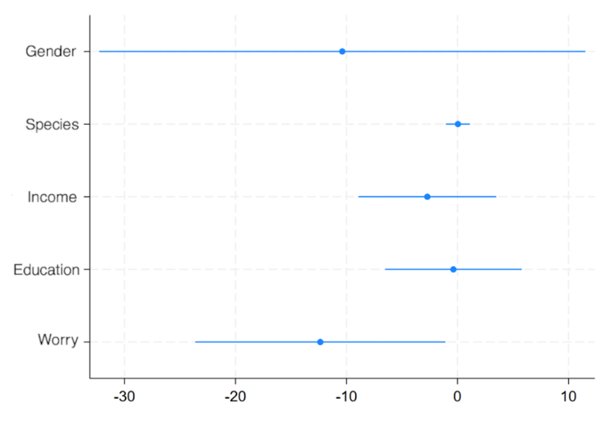
Figure 1: Coefficients and 95% confidence intervals for non-spatially differentiated variables of the Tobit model.
Regarding the socio-demographic variables, somewhat surprisingly (as also shown in Figure 1), they had no significant effect on WTA in the Tobit analysis. The respondent’s Gender did not show a statistically significant impact on. Income had a negative coefficient (suggesting lower-income households might demand slightly more compensation), but it was not statistically significant. Although one might expect lower-income individuals to demand higher compensation - since such payments could represent a relatively larger share of their income - or, on the other hand, higher-income respondents to demand more because they place a greater intrinsic value on biodiversity, these countervailing mechanisms appear to have offset one another. Similarly, respondents’ Education level did not have a significant impact on stated WTA. Although higher education often correlates with greater environmental awareness, it did not translate into a consistent pattern in compensation demanded, suggesting that – regardless of education – when it comes to accepting money for environmental loss, respondents behaved in a comparable way in this scenario. These findings suggest that ethical or cognitive factors—rather than socio-demographic status—predominantly drive compensation expectations for biodiversity loss. Finally, the number of affected species that respondents believed would suffer (an indicator of perceived scope of damage) had a positive but statistically insignificant coefficient. This lack of significance may reflect substantial uncertainty in people’s perceptions of species impacts and/or limited understanding of the relative magnitude of changes represented by this indicator.
Next, based on the estimated regional coefficients (αₖ), the mean WTA for each protected area and corresponding NUTS2 region was computed. Figure 2 illustrate the average WTA per household across Greece for two damage (time horizon) scenarios. The spatial differentiation of WTA values reveals that, in the recoverable-damage scenario, the highest compensation expectations are found in the Peloponnese Region, followed by the Ionian Islands, Attica, and Crete. Under permanent damage, WTA values rise sharply in the southern regions, displaying a clear latitudinal gradient. The lowest values appear in Eastern Macedonia and Thrace, while the highest are recorded in Crete. These results showed a high degree of similarity with a recent assessment of an ecological index: the ratio of threatened species to the total number of species per region, in Greece (Spiliopoulou et al., 2021). This alignment suggests that respondents’ valuations implicitly reflect the underlying ecological reality of their regions. Furthermore, the comparison of these (WTA) scenarios indicates that people required roughly double (or more) money as compensation if the environmental damage was irreversible, reflecting the notion that permanent loss of biodiversity requires substantially greater compensation.
To assess the robustness of the Tobit estimates, an Ordinary Least Squares (OLS) model was also estimated using the logarithmic transformation of the WTA variable (lnWTA), according to which the coefficients can be interpreted as approximate percentage changes in WTA. The OLS regression employed the same explanatory variables as the Tobit model, including the Horizon dummy, and yielded an overall R² = 0.386 and Adjusted R² = 0.382 (F = 120.3, p < 0.001). As shown in Figure 3, the OLS results closely mirror those of the Tobit model, confirming the robustness of the main findings. The permanent damage scenario exhibited a large and highly significant positive effect on ln(WTA): a one-unit increase (from temporary to permanent loss) raised the predicted WTA by about 1.10 points, corresponding to an approximate 200% increase in actual compensation levels. Among the explanatory factors, Worry remained a strong and significant predictor (p < 0.01), reinforcing that respondents more concerned about biodiversity demanded higher compensation.
In contrast to the Tobit model, Education displayed a significant negative association with ln(WTA) (p < 0.01), suggesting that more educated individuals required lower compensation - possibly reflecting greater environmental awareness or intrinsic conservation motivation rather than material compensation motives. Income showed a positive but only marginally significant effect (p ≈ 0.06), and Gender remained not significant. The perceived number of affected species (scope of damage) also remained statistically insignificant, likely due to uncertainty in respondents’ perception of biodiversity loss.

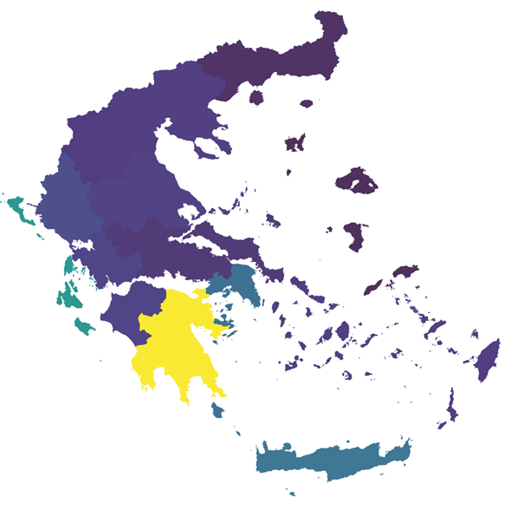
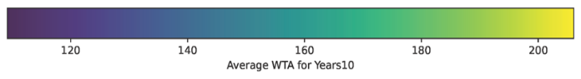
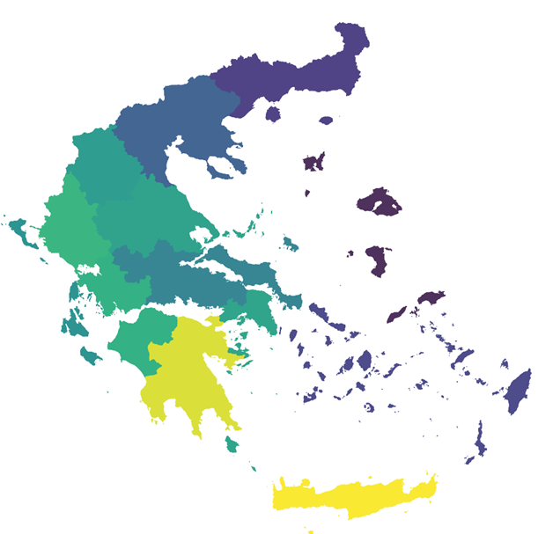
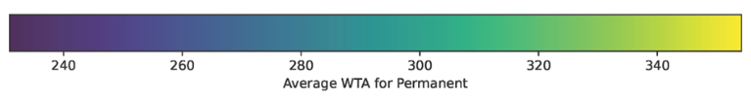
Figure 2: Willingness to Accept (WTA) compensation estimates for biodiversity costs per household, by Region (NUTS2) in the scenario of: (a) damage recoverable through natural restoration within 10 years, (b) permanent damage not recoverable through natural restoration.
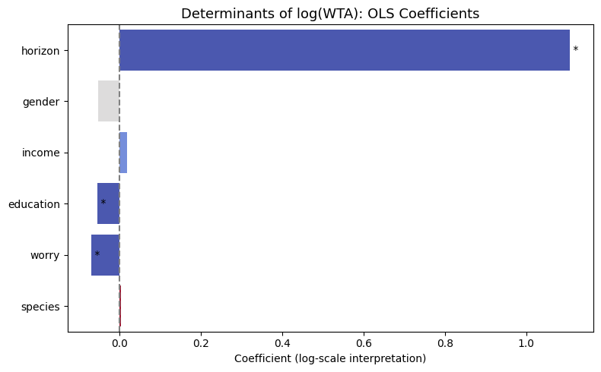
Figure 3: Determinants of ln(WTA): OLS Coefficients
In general, the OLS robustness check supports the Tobit findings, reinforcing that attitudinal and cognitive factors (such as Worry and Horizon) are more influential than basic demographics in shaping individuals’ willingness to accept compensation for biodiversity loss. Additionally, the OLS model adds the nuance that education might play a role (something the Tobit didn’t flag). Importantly, it should be emphasized that no variable showed a conflicting direction of effect between the two models, underscoring the consistency and robustness of the results.

3.2 Determinants of Compensation Acceptance and Protest Responses
Beyond the monetary values themselves, an important aspect of our findings concerns the heterogeneity in respondents’ willingness to accept compensation at all. As noted, a great portion of the sample (about 67.6% of respondents) refused any amount of compensation, essentially taking a principled stand that no trade-off was acceptable for the loss of biodiversity. In order to distinguish protest responses from the non-acceptance of compensation, we used two binary regression models (see Section 2.2). The results reveal distinct patterns aligned with respondents’ environmental attitudes.
In the first mode (acceptance model), the probability of accepting some compensation was significantly higher among respondents who perceived biodiversity loss as harmful to human well-being. In particular, those who strongly agreed that biodiversity loss poses serious threats to human health (Health) or to quality of life (QoL) were more likely to accept compensation for a delay in restoration. Namely, the estimated AMEs (Figure 4) indicate that moving from neutral to strong agreement on the Health or QoL impacts of biodiversity loss increases the acceptance probability by roughly +3 to +5 percentage points, all else equal. This suggests a risk-awareness effect, according to which respondents who recognize tangible personal or social risks from biodiversity degradation tend to be more open to natural remediation through compensation (perhaps viewing compensation as part of a solution to address those risks).
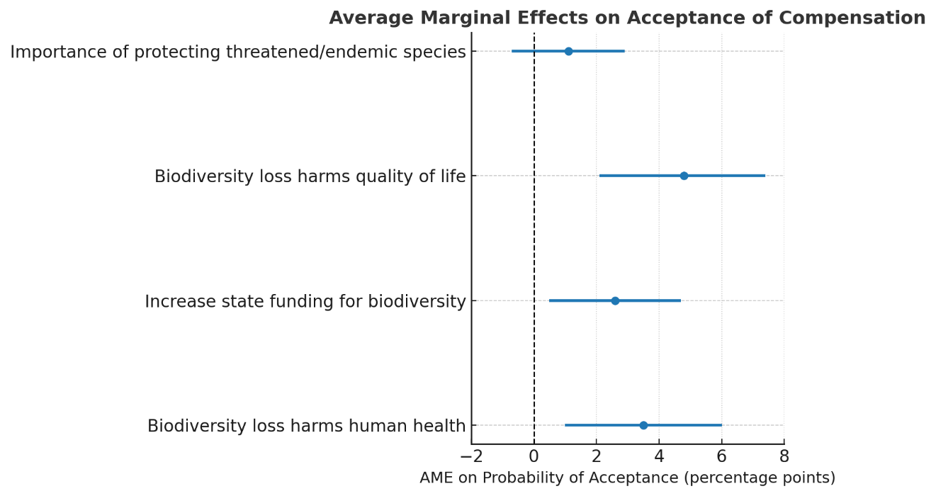
Figure 4. Average Marginal Effects of attitudinal variables on the probability of accepting compensation (WTA) for biodiversity loss. Positive values indicate a higher likelihood of acceptance for a one-unit increase in the predictor. Bars show AMEs with 95% confidence intervals.
The perception that increased state funding for biodiversity (StateFund) is necessary also exerts a positive effect (about +1 to +4 percentage points). At first glance, one might expect that if someone strongly believes the state should fund biodiversity protection, they might not want individual compensation (preferring direct government action instead). However, our finding suggests that these attitudes are not necessarily mutually exclusive. Respondents who favor greater state involvement also tend to view structured compensation schemes positively. In other words, they may perceive compensation as one part of a broader responsibility that includes active government action (i.e. they may seek state action while remaining receptive to compensation within a polluter-pays context). Finally, the value placed on protecting threatened and endemic species is positively but modestly related to acceptance, capturing the ethical appreciation of nature’s intrinsic worth alongside utilitarian considerations.
In the second model (protest model), we see that moral and institutional attitudes seem to play a greater role (Figure 5). Namely, respondents who emphasized government responsibility for environmental protection were more likely to protest, refusing compensation on principle. For example, higher agreement with the statement that “we need to increase state funding for biodiversity protection” was associated with a higher probability of a protest response (AME on protest ≈ +2 percentage points). This aligns with an ethical stance grounded in the idea that biodiversity should be protected by institutions and polluters, not traded for private compensation. Meanwhile, those who strongly felt that biodiversity loss harms health (Health) or quality of life (QoL) were somewhat less likely to protest (their protest probability was 4–6 percentage points lower for each step of stronger agreement on these impact statements). This pattern suggests that when faced with a tangible risk to biodiversity people may be more willing to accept compensation as a pragmatic response, rather than to reject it categorically. Once again, the intrinsic-value attitude toward species protection has a negligible or mixed effect.
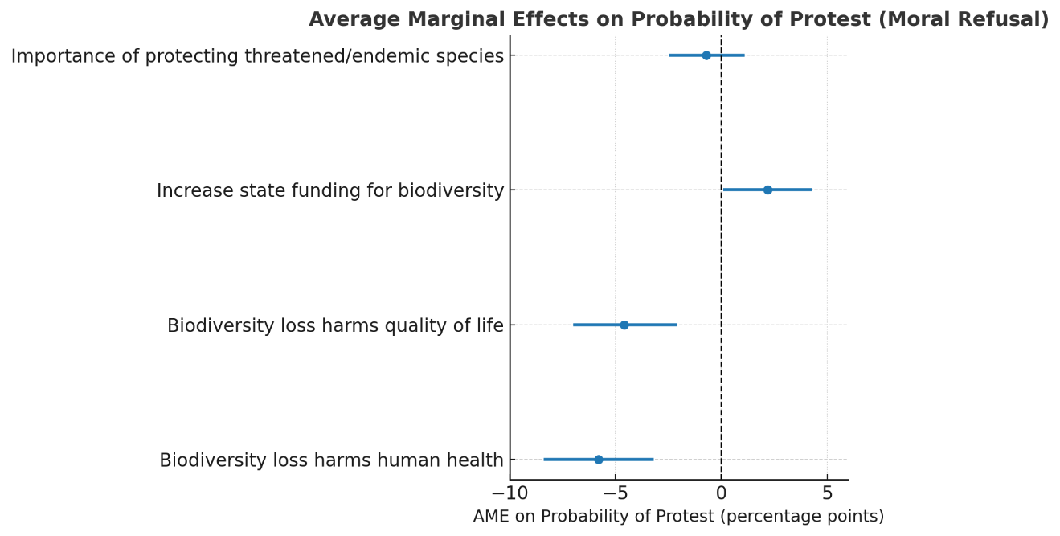
Figure 5. Average Marginal Effects of attitudinal variables on the probability of a protest response (moral refusal to accept compensation). Negative values indicate that an increase in the predictor reduces the likelihood of protesting. Bars show AMEs with 95% confidence intervals.
Taken together, these findings delineate two complementary attitudinal dimensions of environmental preferences: (a) a risk-awareness dimension (health and quality-of-life beliefs), associated with acceptance of compensation, and (b) a moral-responsibility dimension (state funding expectations), associated with ethical refusal based on fairness principles and the polluter-pays logic. This duality supports the interpretation that a substantial share of “non-acceptance” is not driven by indifference or protest bias, but by moral beliefs about justice, responsibility, and the intrinsic value of biodiversity. In other words, we observe a segmentation between respondents who are pragmatic (willing to accept money to mitigate an acknowledged loss) and those who are principled (unwilling to accept money because they view the loss as fundamentally unacceptable or a responsibility of others to fix).

3.3 Latent Class Analysis of Protest Responses
To further explore heterogeneity among the protest respondents, we applied a Latent Class Analysis as described in Section 2.3. The LCA was conducted on the subsample of 852 genuine protesters (i.e., those who refused compensation on moral/institutional grounds). The model identified four latent classes with distinct profiles. The estimated class shares were approximately 39.9%, 25.0%, 24.8%, and 10.3% of the protester subgroup, respectively. The four-class specification minimized the Bayesian Information Criterion (BIC), indicating the best model fit and supporting the presence of meaningful heterogeneity within the protester subgroup.
Across all classes, respondents demonstrated consistently negative evaluations of environmental conditions (biodiversity loss, habitat degradation, pollution, and climate change concern), together with strong endorsement of environmental responsibility principles (polluter-pays principle, government and citizen responsibility, and urgency of restoration). This overall pattern, as illustrated in Figure 6, shows that protest respondents are highly environmentally conscious, differing mainly in the intensity and moral framing of their attitudes rather than in direction.
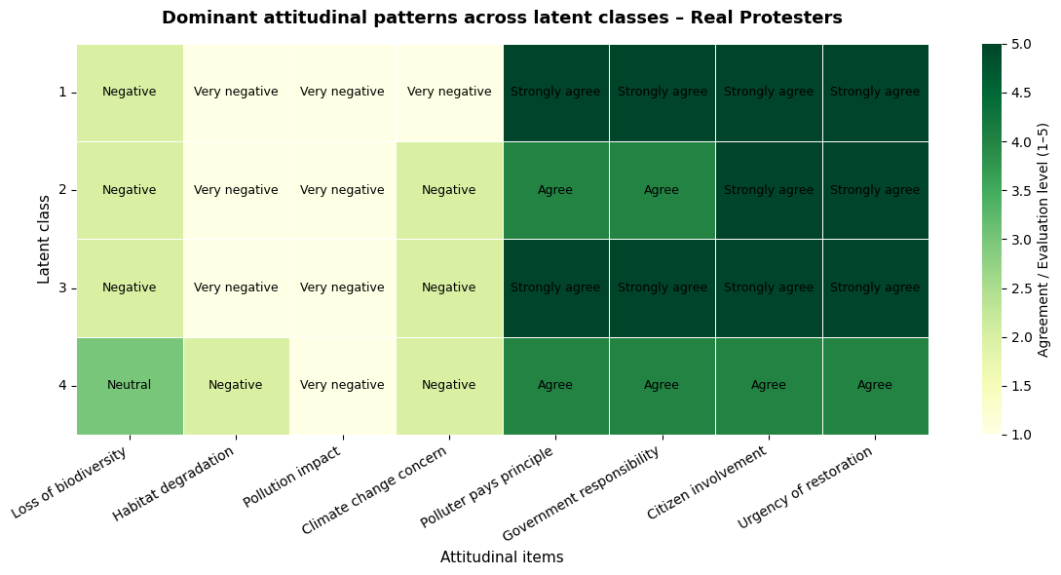
Figure 6. Attitudinal heatmap of the four latent classes among protest respondents. Each row represents one latent class (Class 1–4), and each column corresponds to an attitudinal item. The color intensity (light to dark green) indicates the mean level of agreement or concern (1 = strongly disagree/very negative, 5 = strongly agree/very positive) for that class on each item.
The characteristics of each class are summarized below:
- Class 1 (≈40% of protesters): This largest class can be described as Environmentally aware and morally engaged. Members of this class tend to be middle-aged (often 40–50 years old) and are more likely female. They typically have higher education (many with postgraduate degrees) and moderate incomes. Attitudinally, they express consistently very pessimistic (negative) perceptions of biodiversity loss, pollution, and climate change, while at the same time strongly agreeing with principles of environmental accountability such as the polluter-pays principle, governmental responsibility, citizen involvement, and the urgency of restoration.
- Class 2 (≈25% of protesters): This class can be labeled Young, partially engaged environmentalists. These individuals are often younger (many in their 20s, including students or early-career professionals) and disproportionately male. They do hold pro-environmental values, but their agreement level with the attitudinal statements is moderate rather than extreme. They recognize biodiversity and environmental problems but show somewhat less consistency in translating that into strong opinions and actions. They refuse compensation, perhaps out of principle, but their convictions on specific points are not as uniformly strong as Class 1.
- Class 3 (≈25% of protesters): This group can be termed as Institutionalists. They are commonly middle-aged, and many are public sector employees or have backgrounds that suggest trust in government solutions. They are well-educated and tend to have a stable socioeconomic status. What distinguishes Class 3 is a consistently high agreement with statements about governmental and institutional responsibility. They also exhibit high trust in regulatory approaches and express that environmental restoration should remain a state obligation. Their environmental concern is high (similar to Class 2), while their refusal of compensation is likely grounded in the conviction that accepting money undermines the institutional obligation to restore the damage.
- Class 4 (≈10% of protesters): The smallest class of protesters reflected politically motivated protesters. They are often younger males with higher education, and many show signs of political engagement or activism. They exhibit neutral to negative environmental evaluations and moderate agreement levels, indicative of a more pragmatic or conditional orientation toward restoration actions.

3.4 Spatial Patterns in WTA and Biodiversity
In addition to individual attitudes, our WTA results, according to Figure 2, seem to exhibit a notable spatial dimension, with a strong correspondence to the spatial distribution of the ecological index of threatened species (see Section 2.4). This correlation suggests that public perceptions of biodiversity importance and compensation expectations are likely to be shaped - consciously or subconsciously - by the ecological significance of their regional environments. To further examine this hypothesis, we implemented a series of spatial autocorrelation analyses using GeoDa software (Anselin, 2024), the results of which are presented below.
First, the Global Moran’s I statistics confirm significant spatial autocorrelation for both the ecological and the WTA variables. For the biodiversity index - i.e. the percentage of threatened species, per area, based on IUCN red list (IUCN, 2019) - Moran’s I was found to be I = 0.812 (p < 0.01), indicating a strong positive spatial clustering (i.e. areas with high biodiversity tend to be near each other and the same holds for those having low biodiversity). Furthermore, the WTA values also showed pronounced clustering (Global Moran’s I = 0.803 for WTA in the 10-year scenario, and I = 0.791 for WTA in the permanent scenario, both p < 0.01). In other words, respondents’ compensation demands are not randomly distributed across space as there are regional “hotspots” of high WTA and, conversely, regions where WTA is consistently lower.
Next, by examining the bivariate Moran’s I between biodiversity and WTA we found a positive and moderate spatial correlation between the biodiversity index and WTA. Specifically, for the 10-year loss scenario, the bivariate Moran’s I was about 0.182 and for the permanent loss scenario 0.191 both indicating a statistically meaningful spatial association. These results suggest that areas with high percentage of threatened species tend to be surrounded by areas with high WTA. In other words, perceived biodiversity significance and compensation expectations appear spatially aligned, indicating that respondents’ WTA is partly informed - consciously or not - by the actual ecological conditions of their regions.
To gain a deeper understanding, we mapped Local Indicators of Spatial Association (LISA) clusters for both the biodiversity index and WTA in both scenarios. These cluster maps reveal the specific regions where clustering occurs. In these maps, each municipality is colored according to significant local spatial clusters: red areas denote High–High clusters, blue areas denote Low–Low clusters, and light colors indicate High–Low or Low–High outliers. Figure 7 presents the LISA cluster map for the biodiversity index. In this map, extensive Low–Low clusters are observed primarily across northern Greece (notably across Epirus, Macedonia, and Thessaly), representing areas with lower shares of threatened species. In contrast, High–High clusters appear in Crete, the Peloponnese and the Attica region (the latter standing out not for the total number of species but for the high proportion of its species classified as threatened).
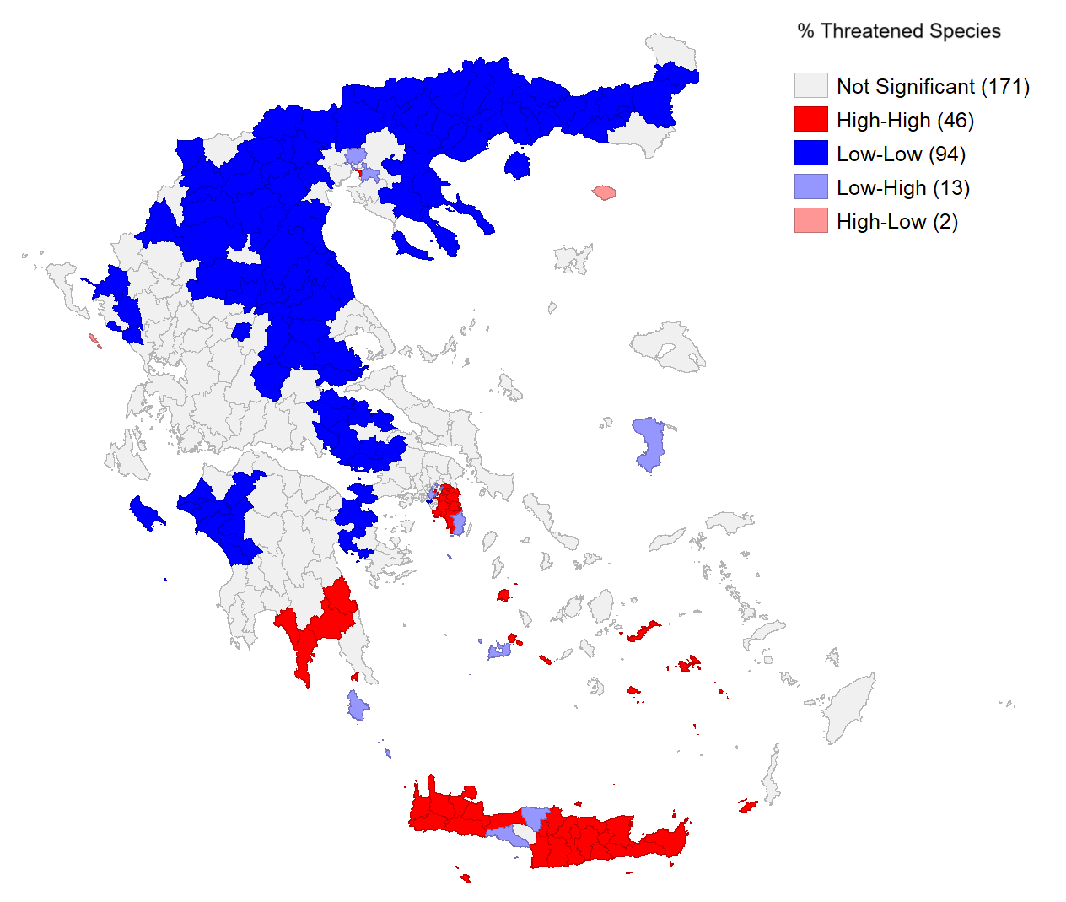
Figure 7. LISA cluster map for the biodiversity index (percentage of threatened species).
Figure 8 displays the local clusters for WTA responses under the recoverable (10-year) biodiversity loss scenario. Based on these results we find large High–High clusters in southern Greece, including much of the Peloponnese and parts of the Ionian islands, where respondents reported higher WTA demands and these areas are contiguous with similarly high-WTA areas. Meanwhile, Low–Low clusters dominate in the northern regions, corresponding to parts of Northern Greece where WTA demands were systematically lower. This north–south polarization suggests that stronger environmental awareness or a greater insistence on compensation is found in the south, which host habitats with a higher concentration of threatened or endemic species. Conversely, in the north, where regions are characterized by lower conservation priority (according to the biodiversity index), people tend to require less compensation for a temporary loss.
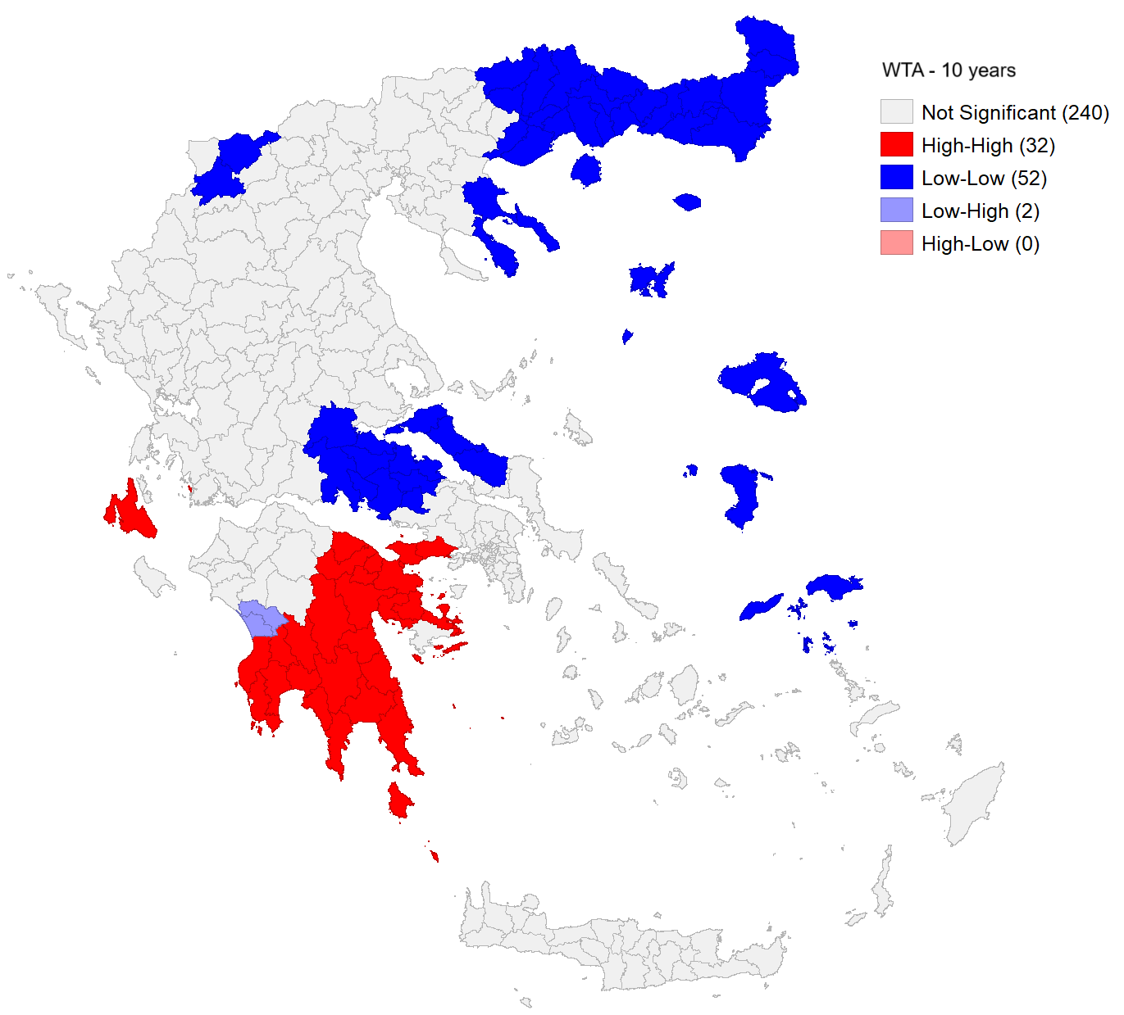
Figure 8. LISA cluster map for WTA – 10-year damage scenario

For the irreversible biodiversity loss scenario (Figure 9), the spatial clustering of WTA is similar but even more pronounced. High–High clusters of very high WTA are concentrated in the southern regions (Peloponnese and Crete), indicating that in these areas respondents demand especially high compensation (often the maximum indicative value in the payment card) for a permanent loss of biodiversity. Low–Low clusters persist in northern and some eastern (island) municipalities, where the WTA for permanent loss is relatively low in a local neighborhood context.

Discussion
The findings of this study provide valuable insights into how individuals perceive and economically value biodiversity loss, revealing both behavioral and spatial heterogeneity in preferences. The results demonstrate that the willingness to accept compensation (WTA) for biodiversity damage is systematically influenced by individual attitudes, socio-demographic characteristics, and spatial context.

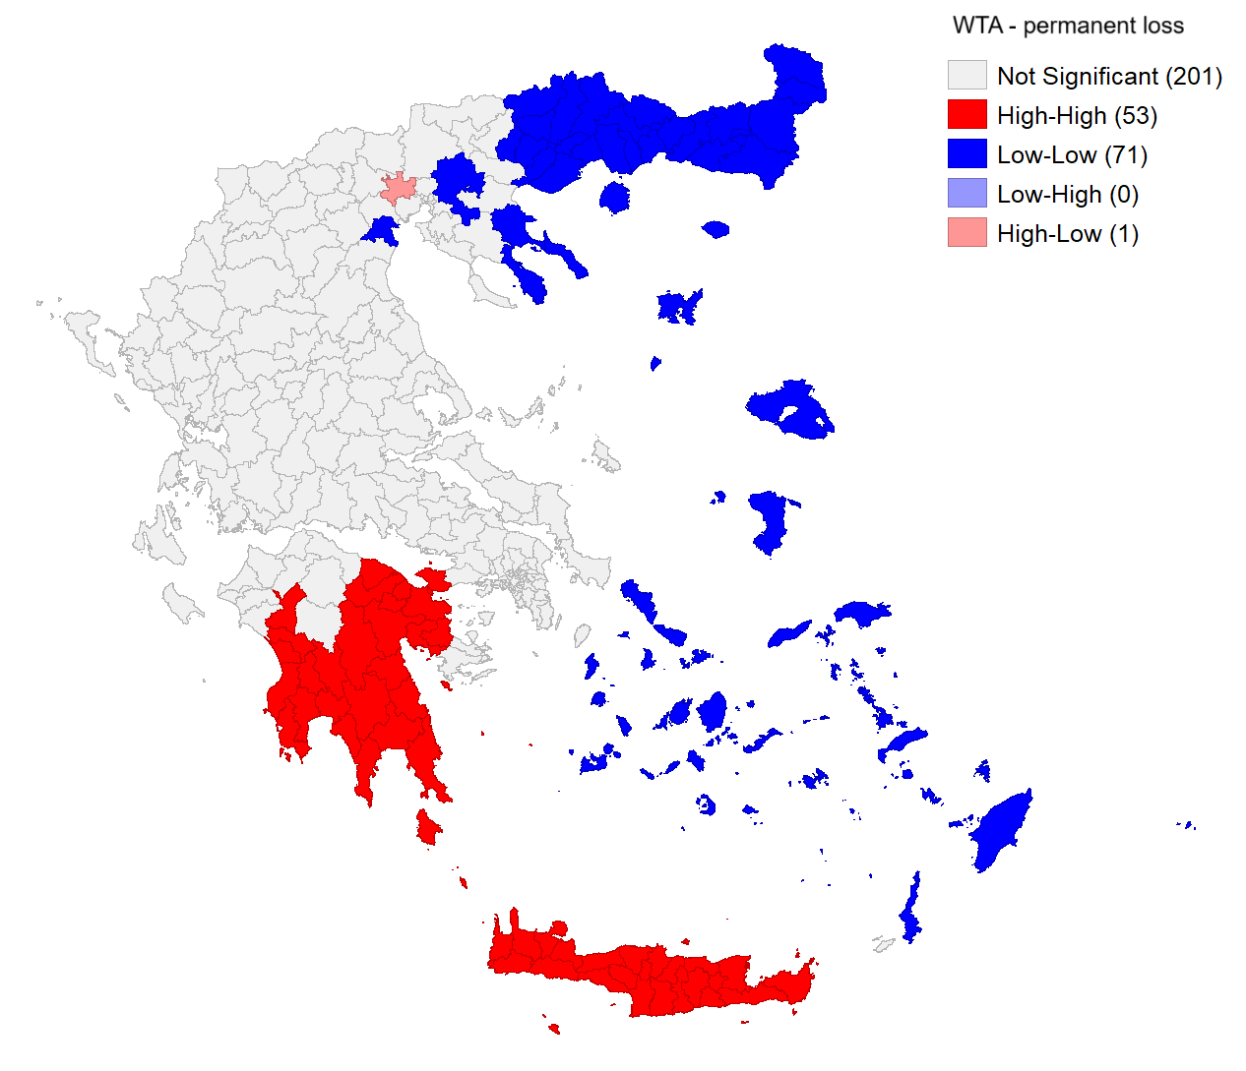
Figure 9. LISA cluster map for WTA – permanent loss scenario.

The econometric analysis indicates that the concern for biodiversity (Worry) is positively associated with WTA, suggesting that individuals with stronger environmental awareness, i.e. those who are emotionally or ethically engaged, ascribe a higher monetary cost to biodiversity damage. This is consistent with the idea that they value lost biodiversity more highly and thus require more compensation to make up for it. Furthermore, the time horizon of environmental degradation has also a significant positive effect, meaning that respondents demand higher compensation for irreversible biodiversity losses than for temporary ones. This finding highlights that individuals differentiate between temporary and permanent environmental risks, assigning higher moral and economic importance to the latter. By contrast, standard demographic variables (income, education, gender) had little to no explanatory power in the Tobit model, with only education emerging as a statistically significant predictor of WTA in the OLS model. These behavioral patterns emphasize that biodiversity valuation is shaped not solely by utilitarian reasoning but also by moral and ethical considerations. This interpretation aligns with broader literature indicating that environmental valuation is often guided by deeply held beliefs and sense of moral responsibility, rather than by purely economic self-interest (Spash, 2000; Dietz et al 2005; Martin-Lopez et al., 2007; Batavia & Nelson, 2017)
Another key finding is that spatial context matters in biodiversity valuation. The Moran’s I and LISA analyses reveal clear spatial dependence, indicating that people’s stated values are influenced by where they live. Moreover, the alignment of the WTA results with the ecological indicator of biodiversity (% of threatened species) enhances the robustness and policy relevance of our results. Specifically, regions with high ecological value - defined by the presence of threatened or endemic species- tend to coincide geographically with higher compensation demands, while low biodiversity value areas align with lower WTA. The LISA maps revealed distinct regional clusters: High–High clusters appear primarily in Crete, the Peloponnese, and Attica, where biodiversity is particularly rich in threatened species. Conversely, Low–Low clusters dominate across much of Northern Greece (Epirus, Macedonia, and Thessaly), where both the biodiversity index and stated compensation levels are lower.
It should be noted that this interpretation was supported and enriched by an expert consultation workshop conducted within the framework of the LIFE–PROFILE project (13-14th June 2024), which gathered 26 biodiversity specialists. The experts largely confirmed the logical coherence of the spatial results, emphasizing that the survey methodology successfully linked public perception with objective ecological indicators. Many noted that respondents in regions of high biodiversity—especially in Crete and parts of southern Greece—appear to recognize their local ecological uniqueness and, consequently, assign higher value to its preservation. Experts further attributed this awareness to factors such as (a) visible environmental pressures from tourism and land-use change, (b) prior experiences of ecosystem service loss, and (c) long-standing public information and awareness campaigns in specific regions. Some also underlined the role of stronger local environmental governance and enforcement, particularly in Crete, in shaping more responsible and informed attitudes toward biodiversity.
Hence, our study suggests that public perceptions and willingness-to-accept are not arbitrary; rather they tend to align with objective ecological conditions, a pattern also observed in previous studies linking economic valuation to actual environmental quality indicators (Farley & Bremer,2017; Zaldo-Aubanell et al. 2024). In practical terms, this is an encouraging result, as it indicates that non-market valuation expressed by the public can, to some extent, capture real environmental priorities. The spatial patterns observed further highlight the importance of considering geography in policy design. For instance, higher compensation or greater conservation funding might justifiably be directed towards regions like the Peloponnese and Crete, where both biodiversity levels and public valuation of biodiversity are particularly high. In this sense, the spatial heterogeneity in our estimates suggests that a one-size-fits-all policy would likely be suboptimal. Instead, incorporating spatial data into policy design could improve both the fairness and effectiveness of environmental liability compensation within the ELD framework. For instance, insurance schemes under the ELD could set higher payout guidelines for regions identified as biodiversity hotspots – particularly where local populations are less willing to accept environmental degradation/loss – thus aligning compensation policies with both ecological values and public expectations.
From a behavioral perspective, our analysis of protest responses highlights the ethical dimension of biodiversity valuation. A substantial share of respondents refused to accept any compensation for biodiversity loss on moral grounds – believing that nature’s loss cannot be repaired or reduced to a monetary value. The logistic regression results showed two distinct yet complementary behavioral patterns. On one hand, pragmatic respondents tend to accept compensation when they are acutely aware of tangible risks, indicating a willingness to mitigate harm to human well-being and health through financial means. On the other hand, ethical protestors reject compensation, driven by fairness principles and the belief that environmental restoration is a shared societal or institutional responsibility rather than a private transaction.
Crucially, our latent class analysis deepened this understanding by revealing that even among these ethical protestors, there is significant heterogeneity in motivations. The four latent classes ranged from morally driven environmental stewards to institutionally oriented citizens and idealistic activists, each guided by a distinct yet coherent set of values. This finding challenges the notion that protest responses are merely noise, random or irrational. Instead, all four classes share a basic consensus on key points – for example, even the more moderate groups agree that biodiversity loss is problematic and that polluters should pay – but they differ in the intensity of their beliefs and their primary focus. Hence, such refusals represent meaningful expressions of environmental ethics and social values. People are effectively saying that biodiversity is “priceless” to them in different ways – whether out of a personal moral duty to nature, a trust in government responsibility, or a justice-based view that rejects commodification of ecological harm. Protest responses can thus serve as qualitative indicators of societal limits to monetization, complementing quantitative WTA metrics when designing insurance and restoration cost guidelines.
This evidence of distinct (moral, cognitive and socio-demographic) protest profiles suggests that outreach and stakeholder engagement strategies should be tailored to different segments of the public, each guided by its own motivations (Reed et al. 2018). Rather than dismissing protest respondents as uncompromising, policymakers addressing environmental accidents and biodiversity loss should recognize and engage with the values underlying their positions. For example, Class 3 protesters (institutionalists) might be satisfied with strong regulatory action and assurances of government-led restoration, whereas Class 1 protesters (environmentally aware and morally engaged individuals) might respond to inclusive decision-making processes that address ethical concerns (e.g., citizen panels or assurances that restoration will be pursued regardless of cost). Additionally, recognizing that many citizens view biodiversity loss as morally unacceptable suggests the need for participatory mechanisms in post-accident restoration planning and compensation schemes (e.g. citizen monitoring boards).

Conclusions
In conclusion, our study underscores that it is both feasible and insightful to integrate ecological and socio-economic approaches in valuing biodiversity. By using a WTA framework aligned with the polluter-pays principle, we obtained monetary estimates of biodiversity loss that are broadly consistent with ecological realities on the ground. The incorporation of spatial analysis revealed clear regional patterns – notably a north–south divide in both biodiversity risk and willingness-to-accept – suggesting that geographic context should be considered when devising compensation and conservation strategies. Furthermore, exploring behavioral heterogeneity through LCA showed that public responses, especially protest refusals, carry meaningful information about ethical stances and cannot be treated as mere noise. Accounting for these diverse social preferences can improve the design and reception of policy tools under the Environmental Liability Directive and similar schemes. Overall, the combination of economic valuation, spatial indicators, and latent attitudinal analysis provides a more holistic understanding of biodiversity’s value.
Future research could extend this framework by: (a) incorporating additional ecological indicators to capture ecosystem functions and services more comprehensively; (b) testing experimental designs, such as deliberative or participatory valuation approaches, to better understand the drivers and consistency of protest responses; and (c) applying ex-post (post-incident) designs to assess whether ethical and spatial valuation patterns persist after real environmental incidents. These options would help to refine how ELD-related insurance and compensation policies account for both ecological integrity and public ethics.

References
- Anselin, L. (2024). An introduction to spatial data science with GeoDa: Volume 1: Exploring spatial data. Chapman and Hall/CRC.
- Anselin, L., Syabri, I., & Kho, Y. (2009). GeoDa: an introduction to spatial data analysis. In Handbook of applied spatial analysis: Software tools, methods and applications (pp. 73-89). Berlin, Heidelberg: Springer Berlin Heidelberg.
- Atkinson, G. and Mourato, S. (2006). Cost-Benefit Analysis and the Environment: Recent Developments. OECD Publishing.
- Bakhtiari, F., Jacobsen, J.B., Strange, N., & Helles, F. (2014). Revealing lay people’s perceptions of forest biodiversity value components and their application in valuation method. Global Ecology and Conservation, 1, 27–42.
- Batavia, C., & Nelson, M. P. (2017). For goodness sake! What is intrinsic value and why should we care? Biological conservation, 209, 366-376.
- Bergkamp, L. and Goldsmith, B. (eds.) (2013). The EU Environmental Liability Directive: A Commentary. Oxford University Press.
- Brown, T.C. and Gregory, R. (1999). Why the WTA–WTP disparity matters. Ecological Economics, 28(3), 323–335.
- Carpenter, S.R., DeFries, R., Dietz, T., Mooney, H.A., Polasky, S., Reid, W.V., & Scholes, R.J. (2006). Millennium ecosystem assessment: research needs. Science, 314(5797), 257–258.
- Carolus, J.F., Hanley, N., Olsen, S.B., & Pedersen, S.M. (2018). A bottom-up approach to environmental cost-benefit analysis. Ecological Economics, 152, 282–295.
- Carson, R. T., & Mitchell, R. C. (1993). The value of clean water: the public's willingness to pay for boatable, fishable, and swimmable quality water. Water resources research, 29(7), 2445-2454.
- Cho, W., Bae, D.H., & Kim, H. (2008). Economic Valuation Methods of Biodiversity. Environmental Engineering Research, 13, 41–48.
- Christie, M., Hanley, N., Warren, J., Murphy, K., Wright, R., & Hyde, T. (2006). Valuing the diversity of biodiversity. Ecological Economics, 58, 304–317.
- Collins, L. M., & Lanza, S. T. (2009). Latent class and latent transition analysis: With applications in the social, behavioral, and health sciences. John Wiley & Sons.
- Costanza, R., d'Arge, R., De Groot, R., Farber, S., Grasso, M., Hannon, B., Limburg, K., Naeem, S., O'neill, R.V., Paruelo, J. and Raskin, R.G., 1997. The value of the world's ecosystem services and natural capital. nature, 387(6630), pp.253-260.
- De Groot, R., Brander, L., Van Der Ploeg, S., Costanza, R., Bernard, F., Braat, L., Christie, M., Crossman, N., Ghermandi, A., Hein, L., & Hussain, S. (2012). Global estimates of the value of ecosystems and their services in monetary units. Ecosystem Services, 1(1), 50–61.
- Díaz, M., Concepción, E.D., Oviedo, J.L., Caparrós, A., Farizo, B.A., & Campos, P. (2020). A comprehensive index for threatened biodiversity valuation. Ecological Indicators, 108, 105696.
- Dietz, T., Fitzgerald, A., & Shwom, R. (2005). Environmental values. Annual Review of Environmental Resources, 30(1), 335-372.
- Dirzo, R. & Raven, P.H. (2003). Global State of Biodiversity and Loss. Annual Review of Environment and Resources, 28, 137–167.
- Farley, K. A., & Bremer, L. L. (2017). “Water is life”: Local perceptions of Páramo grasslands and land management strategies associated with payment for ecosystem services. Annals of the American Association of Geographers, 107(2), 371-381.
- Freeman, A.M. III (2003). The Measurement of Environmental and Resource Values: Theory and Methods. Resources for the Future, Washington, DC.
- Gray, C.L., Hill, S.L., Newbold, T., Hudson, L.N., Börger, L., Contu, S., Hoskins, A.J., Ferrier, S., Purvis, A., & Scharlemann, J.P. (2016). Local biodiversity is higher inside than outside terrestrial protected areas worldwide. Nature Communications, 7, 12306.
- Hanemann, W.M. (1999). The economic theory of WTP and WTA. In Bateman, I. & Willis, K. (eds.), Valuing Environmental Preferences: Theory and Practice of the Contingent Valuation Method in the US, EU, and Developing Countries (pp. 96–110). Oxford University Press.
- Helm, D. & Hepburn, C. (2012). The economic analysis of biodiversity: an assessment. Oxford Review of Economic Policy, 28, 1–21.
- Horowitz, J.K. & McConnell, K.E. (2002). A review of WTA/WTP studies. Journal of Environmental Economics and Management, 44(3), 426–447.
- Hunter, L. & Brehm, J. (2003). Qualitative insight into public knowledge of, and concern with, biodiversity. Human Ecology, 31, 309–320.
- IUCN (2019) The IUCN red list of threatened species. IUCN, Version 2019–2
- Keil, P., Storch, D. & Jetz, W. (2015). On the decline of biodiversity due to area loss. Nature Communications, 6, 8837.
- Kim, Y., Kling, C.L., & Zhao, J. (2015). Understanding behavioral explanations of the WTP–WTA divergence through a neoclassical lens: implications for environmental policy. Annual Review of Resource Economics, 7, 169–187.
- Lancsar, E., & Louviere, J. (2006). Deleting ‘irrational’responses from discrete choice experiments: a case of investigating or imposing preferences?. Health economics, 15(8), 797-811.
- Leadley, P., Gonzalez, A., Obura, D., Krug, C. B., Londoño-Murcia, M. C., Millette, K. L., ... & Xu, J. (2022). Achieving global biodiversity goals by 2050 requires urgent and integrated actions. One earth, 5(6), 597-603.
- Leeper, T. J. (2017). Interpreting regression results using average marginal effects with R’s margins. Available at the comprehensive R Archive Network (CRAN), 32, 1-32.
- Legakis, A., Constantinidis, T., & Petrakis, P.V. (2018). Biodiversity in Greece. In Pullaiah, T. (ed.), Global Biodiversity (pp. 71–113). Apple Academic Press.
- Martín-López, B., Montes, C., & Benayas, J. (2007). The non-economic motives behind the willingness to pay for biodiversity conservation. Biological conservation, 139(1-2), 67-82.
- Nunes, P. & Nijkamp, P. (2011). Biodiversity: Economic Perspectives. Research Memorandum 2011-2, Faculty of Economics and Business Administration, VU University.
- Ojea, E., Nunes, P.A., & Loureiro, M.L. (2010). Mapping biodiversity indicators and assessing biodiversity values in global forests. Environmental and Resource Economics, 47, 329–347.
- Reed, M.S., Vella, S., Challies, E., De Vente, J., Frewer, L., Hohenwallner‐Ries, D., Huber, T., Neumann, R.K., Oughton, E.A., Sidoli del Ceno, J. and Van Delden, H., (2018). A theory of participation: what makes stakeholder and public engagement in environmental management work? Restoration ecology, 26, S7-S17.
- Samuelson, P.A. (1954). The pure theory of public expenditure. The Review of Economics and Statistics, 36(4), 387–389.
- Schultz, E.T., Johnston, R.J., Segerson, K., & Besedin, E.Y. (2012). Integrating ecology and economics for restoration: using ecological indicators in valuation of ecosystem services. Restoration Ecology, 20(3), 304–310.
- Spash, C. L. (1997). Ethics and environmental attitudes with implications for economic valuation. Journal of Environmental Management, 50(4), 403-416.
- Spash, C.L. & Hanley, N. (1995). Preferences, information and biodiversity preservation. Ecological Economics, 12(3), 191–208.
- Spash, C. L. (2000). Ethical motives and charitable contributions in contingent valuation: Empirical evidence from social psychology and economics. Environmental Values, 9(4), 453-479.
- Spiliopoulou, K., Dimitrakopoulos, P.G., Brooks, T.M., Kelaidi, G., Paragamian, K., Kati, V., Oikonomou, A., Vavylis, D., Trigas, P., Lymberakis, P., Darwall, W., Stoumboudi, M.Th. & Triantis K.A. (2021). The Natura 2000 network and the ranges of threatened species in Greece. Biodiversity and Conservation, 30, 945–961.
- Strange, N., zu Ermgassen, S., Marshall, E., Bull, J.W., & Jacobsen, J.B. (2024). Why it matters how biodiversity is measured in environmental valuation studies compared to conservation science. Biological Conservation, 292, 110546.
- Veisten, K., Navrud, S., & Valen, J.S. (2006). Lexicographic preference in biodiversity valuation: tests of inconsistencies and willingness to pay. Journal of Environmental Planning and Management, 49(2), 167–180.
- Vermunt J. K., Magidson J. (2004). Latent class analysis. In Lewis-Beck M. S. (Ed.), The Sage encyclopedia of social science research methods (pp. 549–553). Thousand Oaks, CA: Sage.
- Wegner, G. & Pascual, U. (2011). Cost-benefit analysis in the context of ecosystem services for human well-being: a multidisciplinary critique. Global Environmental Change, 21(2), 492–504.
- Yuan, R., Zhang, N., & Zhang, Q. (2024). The impact of habitat loss and fragmentation on biodiversity in global protected areas. Science of the Total Environment, 173004.
- Zaldo-Aubanell, Q., Mas-Ponce, A., Asbert, G., Clota, B., Isnard, M., Proia, L., Bach A. & Mateo, S. S. (2024). Public perception vs ecological quality status: Examining the ecological restoration of the Congost River's Environment. Heliyon, 10(14).

